MISR UNIVERSITY FOR SCIENCE & TECHNOLOGY

FACULTY OF ENGINEERING MECHATRONICS DEPARTMENT

**Proposal for (ADAS) Graduation Project**

Submitted by.

|  |  |
| --- | --- |
| Name | ID |
| Abanob Malak | 95689 |
| Kareem Ahmed | 95635 |
| Omar Mohamed | 95668 |
| Magdy Maged | 91672 |
| Essam Alaa | 91679 |

Supervised by

Dr. Bahaa Eldin Mohamed

Table of Contents

Abstract 3

Introduction 3

Literature Review 5

(Mechanical) 5

Ackerman Chassis: 5

(Electrical) 5

Project Objective: 5

Features: 6

1. Blind Spot Detection (BSD): 6

2. Adaptive Cruise Control (ACC): 6

3. Bump Detection (BD): 6

4. Traffic sign Recognition (TSR): 6

Expected Outcomes 8

Conclusion 9

Expected Cost 9

# Abstract

Advanced Driver Assistance Systems (ADAS) are a cornerstone of modern automotive technology, designed to enhance vehicle safety and improve the driving experience. This abstract discusses the core components, functionalities, and advantages of ADAS. By integrating sensors, cameras, and radar systems, ADAS significantly reduces accidents and human errors, contributing to safer roads. Beyond safety, ADAS also alleviates driver cognitive load by providing real-time information and support, leading to increased comfort and reduced fatigue.

**Our Project is specifically handling the following systems:**

* **Traffic sign Recognition**
* **Adaptive Cruise Control**
* **Bump Detection**
* **Blind Spot Detection**

# Introduction

A driver is one of the “best sensors in the vehicle” and is the main responsible for avoiding crashes. But still, a large proportion of crashes are attributed to the driver errors. A survey was conducted to identify the critical reason for each crash, and the “National Sample Of US crashes” from 2005 to 2007 was examined. It was noted that the driver error was the critical reason contributing to 94 percentage of crashes as shown in Fig.

These errors included recognition errors, decision errors, performance errors, and nonperformance errors. Recognition errors are the result of inattention and inadequate surveillance of the driver; decision errors arise due to the misjudgments of the driver; performance errors arise due to overcompensation, poor directional control, etc.; and nonperformance errors arise due to sleeping and fatigue.

The development and deployment of the new in-vehicle technologies to counteract these driver errors and hence to support the driver to prevent crashes is ongoing. Advanced driver assistance systems (ADAS) are a group of vehicle technologies that warn the drivers timely regarding the risky or hazardous situations to avoid crashes. Some ADAS technologies actively and automatically intervene to avoid hazardous situations or when the system detects that a crash is imminent. ADAS technologies are the precursor to autonomous vehicles and, depending on the combination of ADAS equipment installed in a vehicle, can allow level 1 to level 2 autonomous driving at the present time as represented in Fig.

(SAE International 2014).

# Literature Review

## (Mechanical)

### Ackerman Chassis:

The robot is built with an Ackerman chassis structure, allowing it to be driven by the rear wheel while being controlled by the front wheel. The front wheel steering mechanism resembles that of a real car, enabling basic driving functions such as forward movement, reverse, and wide-radius steering. However, it does not support in-place steering. The Ackerman chassis offers not only excellent steering capabilities but also a certain degree of climbing ability.

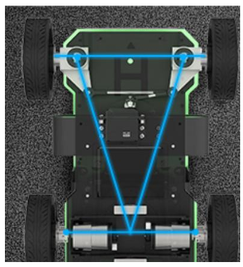

## (Electrical)

### Project Objective:

ADAS can work an important role in many factors to reduce the number of crashes cases as possible using the power of sensors and Machine learning algorithms to analyze the environment around the vehicle and take the required action in the suitable time

**These factors are:**

**1-Blind Spot Detection.**

**2-Lane Departure.**

**3-Adaptive Cruise Control.**

**4-Bump Detection.**

**5-Traffic Sign Recognition.**

**6- Automatic Emergency Braking.**

# Features:

## 1. Blind Spot Detection (BSD):

BSD technology helps drivers identify vehicles in their blind spots and alerts them to avoid dangerous maneuvers.

## 2. Adaptive Cruise Control (ACC):

ACC that adjusts the vehicle's speed automatically to maintain a safe distance from the vehicle ahead.

## 3. Bump Detection (BD):

Bump detection systems are equipped to detect and alert drivers of speed bumps and other road irregularities.

## 4. Traffic sign Recognition (TSR):

Traffic Sign Recognition can interpret and display traffic signs to keep drivers informed about speed limits, no-entry signs, and more.

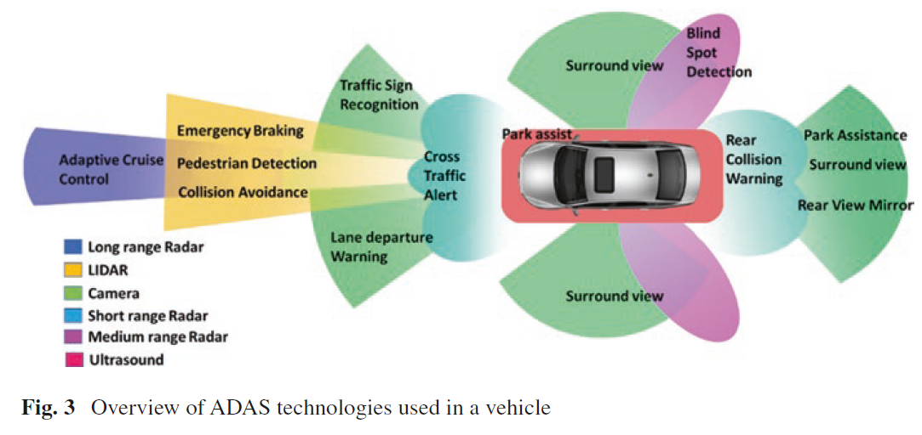

**Proposed Solution**

The proposed solution involves the integration of various Advanced Driver Assistance Systems (ADAS) to enhance vehicle safety and driver experience. The primary objective is to develop a comprehensive system that incorporates the following technologies:  
  
1- Bump Detection:  
 - Implementation of sensors and machine learning algorithms to detect road bumps and irregularities. The system will alert the driver in real-time, enabling them to take precautionary measures, thereby reducing the risk of vehicle damage and ensuring a smoother driving experience.  
  
2- Precise Lane Tracking:  
 - Utilizing camera-based vision systems and algorithms to accurately track lane markings on the road. This system will alert drivers when the vehicle is unintentionally drifting out of its lane, helping to prevent accidents caused by driver inattention or fatigue.  
  
3- Road Sign Interpretation:  
 - The integration of image recognition technology to identify and interpret traffic signs. This system will display relevant traffic information on the vehicle's dashboard, ensuring that the driver is always informed about speed limits, no-entry zones, and other critical road signs.

**4- Blind Spot Detection:**  
 - Deployment of sensors and cameras to monitor areas around the vehicle that are typically difficult for the driver to see. The system will provide visual or auditory warnings when another vehicle is detected in the blind spot, helping to avoid collisions during lane changes.

**5- Adaptive Cruise Control:**  
 - Developing a system that automatically adjusts the vehicle’s speed to maintain a safe distance from the vehicle ahead. This feature not only enhances driving comfort but also contributes to overall road safety by reducing the likelihood of rear-end collisions.  
  
**6- Automatic Emergency Braking:**  
 - Implementation of a system that uses sensors to monitor the road ahead for potential collisions. If a hazard is detected and the driver does not respond in time, the system will automatically apply the brakes to prevent or mitigate the impact.  
  
Each of these components will be integrated into a single ADAS platform, enabling seamless interaction between the systems. The platform will be tested under various driving conditions to ensure reliability and effectiveness. The solution is designed to be scalable and adaptable to different vehicle types, making it a viable option for widespread implementation in the automotive industry.

# Expected Outcomes

1. Providing the graduate student with an opportunity to apply what they have learned and implement it in their specific field of specialization.

2. Allowing the student to practice and apply professional ethics and work within a team before entering the workforce.

3. Offering the opportunity to invest in and find a sponsor for the project idea, facilitating its implementation in practical applications.

4. Preparing the graduate student to be an effective contributor in all scientific and research fields.

5. Ensuring that the graduate student can utilize their practical abilities, cognitive structures, and skills in writing, research, and documentation during their studies.

# Conclusion

In conclusion, advanced driver assistance systems (ADAS) have significantly contributed to enhancing vehicle safety and improving overall driving experiences. The integration of blind-spot detection systems has effectively reduced the occurrence of accidents caused by lane changes, particularly in scenarios where drivers have limited visibility. Lane departure systems have proven valuable in preventing unintentional lane drifts and reducing the risk of collisions due to driver inattentiveness or fatigue. Traffic sign recognition systems have played a crucial role in improving compliance with traffic regulations. By accurately identifying and displaying relevant traffic signs, these systems help drivers stay informed and make better decisions while on the road.

Overall, advancements in ADAS technologies have demonstrated their effectiveness in preventing accidents, reducing human error, and enhancing overall road safety. As these systems continue to evolve, they have the potential to significantly reduce the number of collisions and make driving experiences safer and more enjoyable for everyone on the road.

# Expected Cost